1.

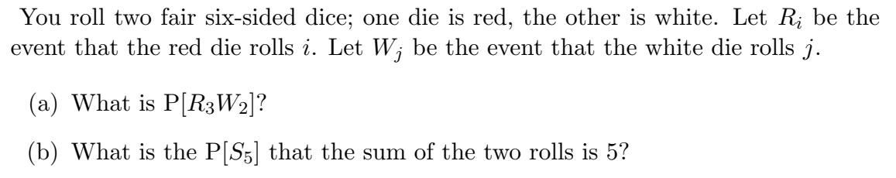

2.

3. 



4.

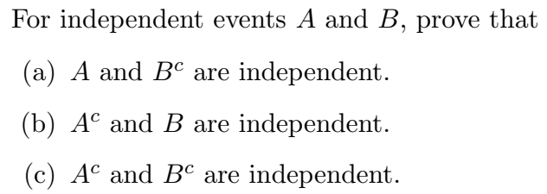

5.

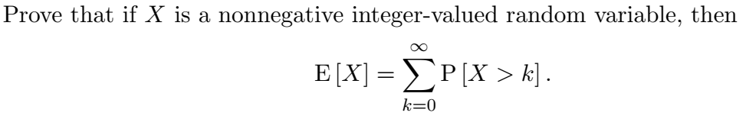

6.

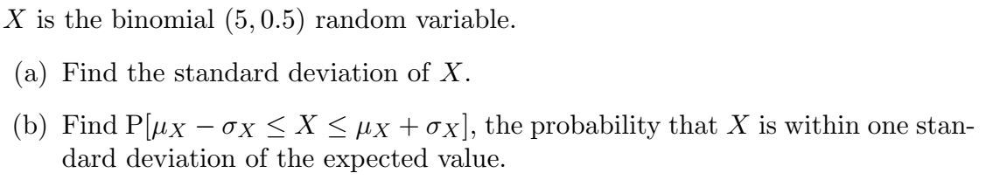

7.



8.

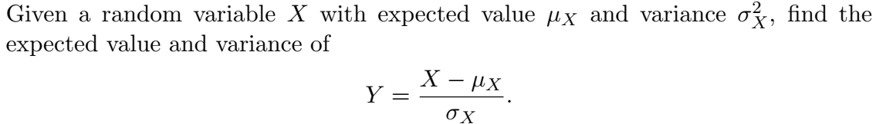

9.

